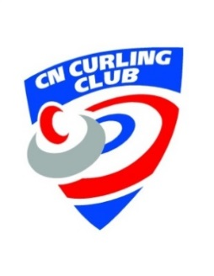

**2023 Off the Rails Bonspiel**

***October 27 - 29, 2023***

**Team Name:** Click or tap here to enter text.

**Contact Name:** Click or tap here to enter text.

**Email:** Click or tap here to enter text.

**Cell Phone #:** Click or tap here to enter text. **Other Phone #:** Click or tap here to enter text.

**Preferred Contact Method --- Email  Text  Phone**

**Team Members:**

**Skip** Click or tap here to enter text. **3rd** Click or tap here to enter text.

**2nd** Click or tap here to enter text. **Lead** Click or tap here to enter text.

**Entry Fee $360 per team**

**One registration form and one payment per team**

**Registration Deadline & Payment due Oct. 18, 2023**

**Email registration to Christina Kulba:** [**ckulba@sasktel.net**](mailto:ckulba@sasktel.net)

Once registered, an *invoice will be emailed to the applicant* and payment can be e-transferred to [*dean*](mailto:dean)*@cncurlingclub.ca*; or

cheque, debit or credit card payments can be made in person

For further information contact:

Christina Kulba – [ckulba@sasktel.net](mailto:ckulba@sasktel.net); 306-221-6546

Dean Longworth, Manager – [dean@cncurlingclub.com](mailto:dean@cncurlingclub.com); 306-382-3088